PROJECT REPORT OF INDUSTRY ORIENTED HANDS ON EXPERIENCE (IOHE)
ON
Resume Builder
submitted in partial fulfilment of the requirements for the award of degree of

BACHELOR OF ENGINEERING
In
COMPUTER SCIENCE AND ENGINEERING

Submitted by: Supervised By:
Sneha Kumari Dr. Rajat Takkar
2211981390 Assistant Professor
BE CSE


DEPARTMENT OF COMPUTER SCIENCE AND ENGINEERING

CHITKARA UNIVERSITY INSTITUTE OF ENGINEERING AND TECHNOLOGY
CHITKARA UNIVERSITY, PUNJAB, INDIA

CONTENTS

S.No. | Title | Page No.
 | Acknowledgement
 | List of Figures and Tables
 | Abstract
1 | Introduction | 5
2 | Methodology | 6
3 | Tools and Technologies | 7
4 | Implementation & Results | 8
5 | Conclusion ,Future Scope & References | 9
6 | Appendices | 10-13

DECLARATION

I hereby certify that the work which is being presented in the project report entitled “Resume Builder” in partial fulfilment of requirement for the award of the degree of Bachelor of Engineering (Computer Science and Engineering) submitted in the department of Computer Science and Engineering at Chitkara University Institute of Engineering and Technology, Chitkara University, Punjab, India, is an authentic record of my own work carried out under the supervision of Dr. Rajat Takkar . The matter presented in this project report has not been submitted in any other university/institute for the award of any degree.

Place: Rajpura Sneha Kumari
Date: 29-04-2026 (2211981390)

This is to certify that the above statement made by the candidate is correct to the best of my knowledge and belief.

Dr. Rajat Takkar
Assistant Professor
Department of Computer Science and Engineering
Chitkara University Institute of Engineering and Technology,
Chitkara University, Punjab, India

ACKNOWLEDGEMENT

First of all, I would like to thank my respected guide and mentor, Dr. Rajat Takkar Sir, whose valuable guidance, support, and encouragement have made this project possible. The knowledge and insight provided by him helped me develop the quality of this project and overcome the obstacles on the way.
Next, I would like to thank the management and staff of Chitkara University for the opportunity and resources provided by them to complete this project successfully.
Moreover, I would like to thank all my faculties who guided me and motivated me in every step of this project. Their guidance and sharing knowledge were helpful in building a foundation for this project.
Further, I would like to thank my friends and fellow students whose cooperation and advice were instrumental in developing this project.
In addition to this, I would also like to thank all those books, documentation, and other online resources, which were useful in gaining new concepts and implementing them successfully.
Lastly, I would like to thank my family members for their unconditional support and encouragement in completing this project.

- Introduction

In the contemporary competitive job market, it is important to have a well-designed and professional resume since it can be very helpful in finding employment. However, many people have problems designing their resumes because of poor guidelines, problems with formatting, and inadequate knowledge of how information should be organized and presented professionally. Poorly structured resumes tend to be less effective since they cannot present one's full potential.
Typically, designing a resume takes much time, especially when basic text editors are used. In most cases, people find it difficult to format information properly and organize sections correctly. Thus, many talented candidates have no chance to receive an invitation to participate in the interview.
As a response to current difficulties related to resume creation, a modern web-based resume builder was created. The project can be regarded as a very useful tool that allows users to create professional resumes quickly and easily. For example, one can use an easy-to-use interface of the application and fill out structured input fields containing personal information, educational background, skills, work experience, etc.
Therefore, the Resume Builder increases the speed of resume design and helps to produce high-quality professional documents that can increase one's chances to get a job.

2. Methodology
2.1 Requirement Analysis
- Registration & Login
- Add personal information, education background, skills and experience
- Choose resume template
- Save resume as pdf file

2.2 System Design
- User Interface/ User Experience design
- Database design
- Flow of data flow in the system

2.3. Frontend Development
- Forms to enter resume information
- Pages to preview resumes
- Responsive design

2.4. Backend Development
- Database management
- User authorization (log-in/sign-up)
- Generation of resumes

2.5. Testing

- User data is stored correctly
- Data display on resumes is correct

2.6. Implementation
- No system issues or problems
- Correct handling of data
- Resume generation is correct
3. Tools and Technologies

3.1. Frontend Technologies
HTML : HTML is used for creating the basic structure of the web pages.
CSS : Styling the application using CSS includes setting colors, fonts, space, etc.
JavaScript: JavaScript can be used for creating interactivity in web applications such as form validations, preview changes, user interactions, etc.
React.js: React.js is a JavaScript library that helps create user interfaces by building reusable components and managing application state.

3.2. Backend Technologies
Node.js: Node.js is a runtime environment for executing JavaScript server-side.
Express.js: Express.js is a web framework for Node.js that helps build RESTful APIs.

3.3. Database
MongoDB: MongoDB is a NoSQL database that stores user data like personal details, education, and work experience.

4. Implementation
The resume builder was designed as a web application aimed at easing the process of creating an online resume. In terms of frontend development, HTML, CSS, and React.js were used for building a responsive interface. User details including personal information, education, skills, projects, and work experience will be collected using forms.
JavaScript, combined with React state, can manage user inputs, which means that users' data will be updated automatically without refreshing the page. After processing all this information, a well-structured and professionally formatted resume will be generated. A real-time preview option was introduced so that users can check their details and correct any mistakes.
On the backend side, Node.js and Express.js were responsible for handling API requests. Data will be stored using MongoDB. Furthermore, a PDF generation tool will allow users to get a professionally formatted document.

5. Results
Resume Builder is an innovative tool that offers an effective and efficient method of creating a professional resume. The first important discovery that I have made during the course of this project is that there is no need to possess any specialized skill set for the purpose of building one's resume using this system. The system makes the entire process much simpler for the users since the need for formatting the resume becomes completely eliminated. As a result of the project, we get an effective and organized platform that facilitates easy creation of one's resume. Users can feed in all of the details such as personal information, education qualifications, skills, experience, etc., which then get formatted automatically. Users will also be able to see a preview of the resume so that it can be edited accordingly. The result produced after the completion of the process would be a fully designed professional resume.

6. Conclusion
Resume Builder web app project is very effective in making professional resumes by utilizing a very efficient and friendly user interface. It efficiently eliminates the burden of formatting, thus, helping in saving the time of the user, since there is no need for the individual to have skills in designing. With the tool, users can simply key in their personal data, academic credentials, skillset and employment experiences and the software generates a professional layout.
It further offers the functionality of enabling users to make corrections using live preview capability before downloading it in a PDF file. This makes it easier for users to print out their resume. Therefore, the project fulfills all its intended objectives of easing resume generation and saving the time of the user. In fact, such a project becomes useful to both job seekers and students who wish to get employed.

7. Future Scope
- Addition of multiple professional and industry-specific resume templates.
- Option to create and manage different resumes for different job roles.
- Integration with job portals for direct job applications using generated resumes.
- Mobile application version for better accessibility and convenience.
- Advanced editing tools for improving resume design and formatting.
- Export options in multiple formats like PDF, DOCX, etc.

8. References
- HTML, CSS, and JavaScript Documentation – https://developer.mozilla.org/
- React Official Documentation (if used) – https://react.dev/
- Tailwind CSS Documentation (if used) – https://tailwindcss.com/

9. Appendices
9.1 ( Code)
resumeController.js
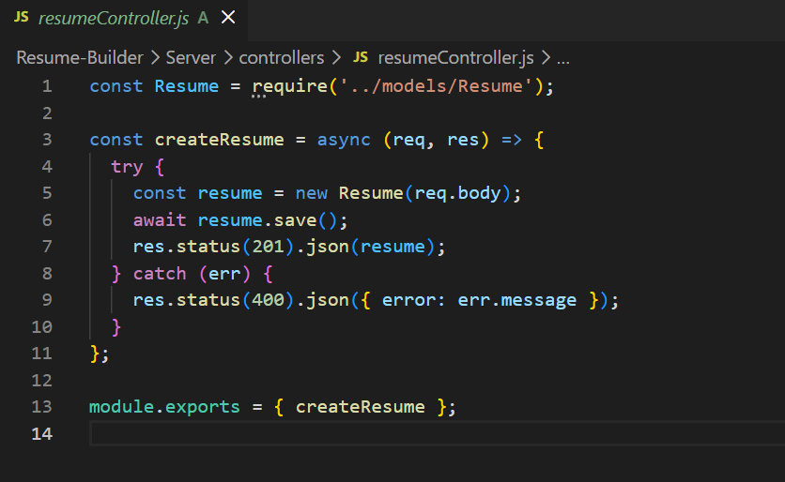

Resume.js
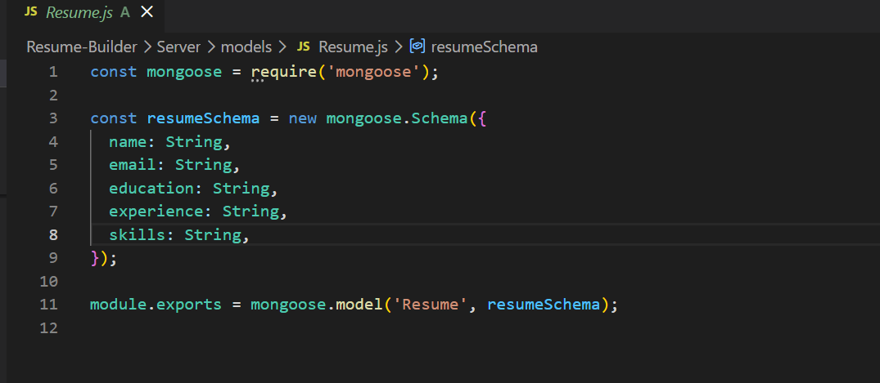

9.2- (Pics)

signIn/signUp page
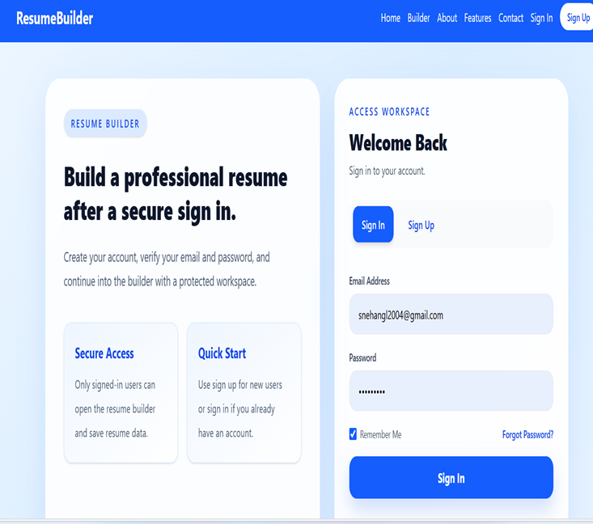

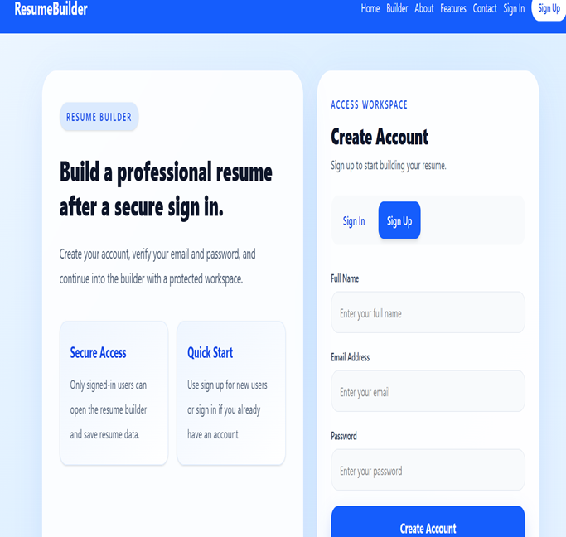

Contact Page
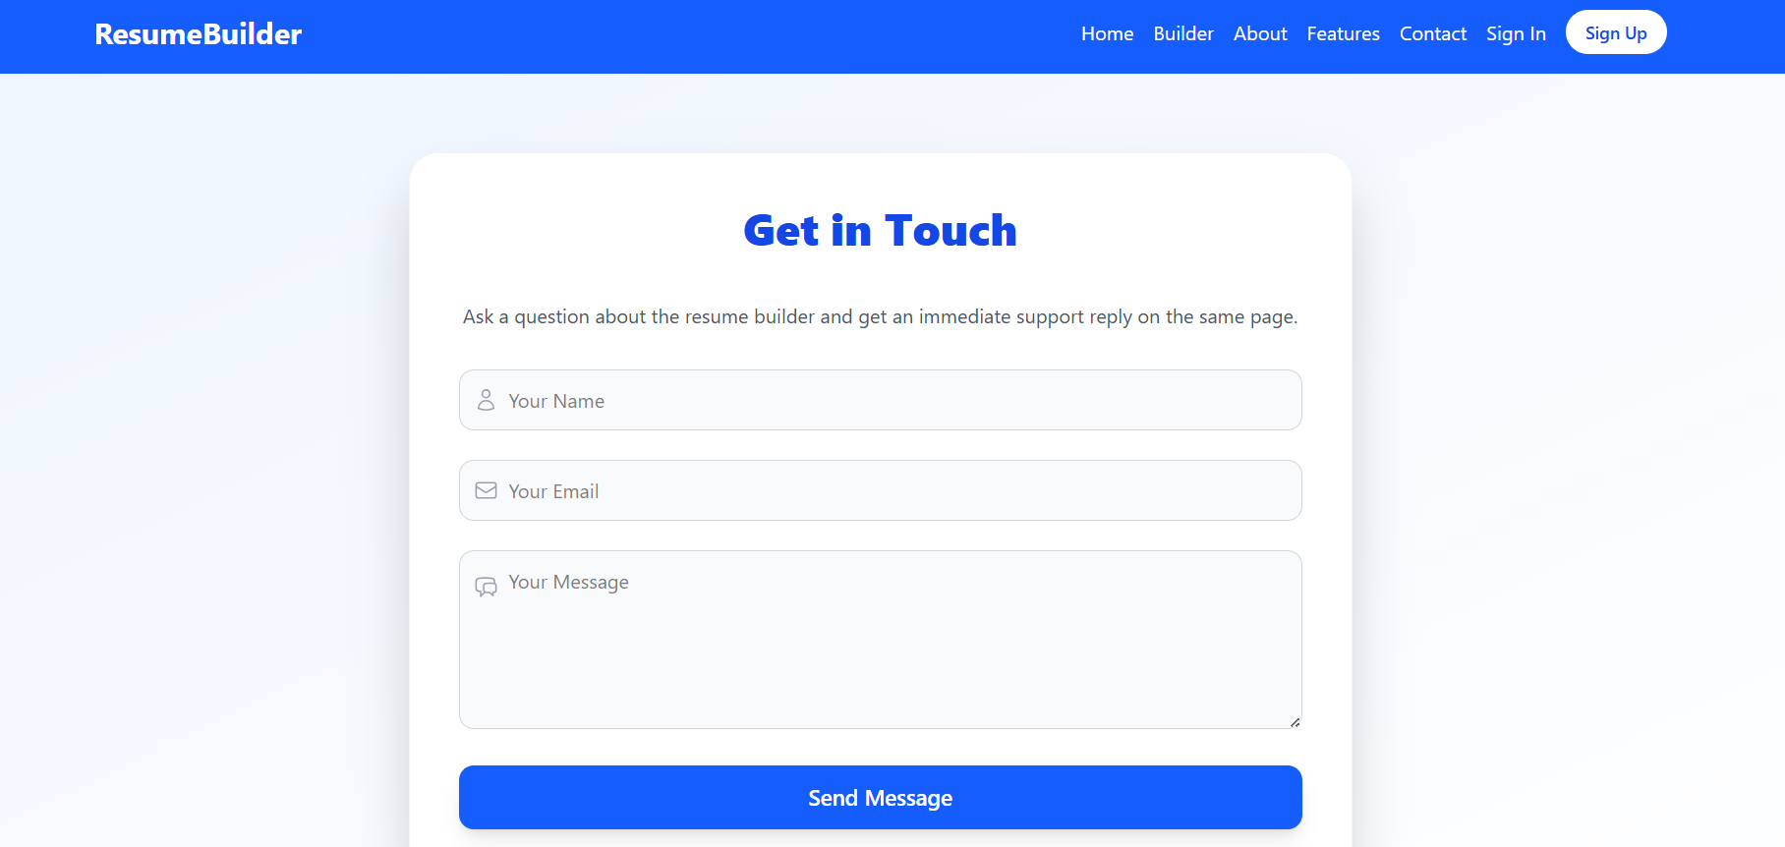

Dashboard Page
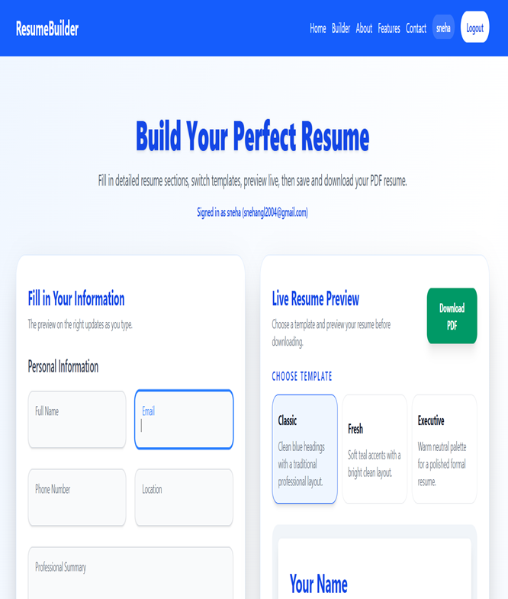

9.3- (Result)
